**Formatting Guidelines: Indigenous Wisdom**

# Title of the Paper [Select Heading 1 from Styles, Font: Georgia, Size: 16, Bold, Spacing 0 before and 0 (zero) after], line spacing 1.15, Left Aligned

**[Space]**

**Author1, Author2 [No special Style to select, Font Georgia, size 14, spacing Zero before and after]**

**1Designation and affiliations: Xxxx. ORCID: 16-digit-number-only. Email:**

**2Designation and affiliations: Xxxx. ORCID: 16-digit-number-only. Email:**

[Space. Use Enter]

[Space]

# Title of the Paper [Select Heading 1 from Styles, Font: Georgia, Size: 16, Bold, Spacing 0 before and 0 (zero) after], line spacing 1.15, Left Aligned

**Abstract**

Font Georgia, size 10, justified, spacing before and after zero, use italics only if necessary.

[Space]

**Keywords***:* Font Georgia, size 10, justified, spacing before and after zero, use italics only if necessary.

[Space]

[Space]

**Heading 1: If it is a section, use size 12.**

**Heading 1 [size 11, justified, spacing before and after 6, line spacing Single all over the body of the article. In case of quotation of poems use spacing before and after 0]**

Start your article here. No indent. Follow the latest APA guidelines all over.

Next paragraph. No indent. Don’t use five spaces etc. If you are quoting more than one line, use the following style for including citations:

Keep the citation in indented form. Don’t make the right side indented. Keep it justified. Same style as in the paragraph. Your citation goes here. (Author’s-last-name, 2010).

For citations inside the paragraph having only one sentence or phrase or clause, follow the same style. Page no can be added. For instance: The presidential struggle for a society free of racial discrimination was still in its infancy, but it allowed Truman to lay the foundations for a “second Reconstruction” (Goldzwig, 2005, p. 104).

If you want to use figures, graphs, images etc. make sure that the image is not more than 800 pix wide. Keep the visual item in the middle of the page

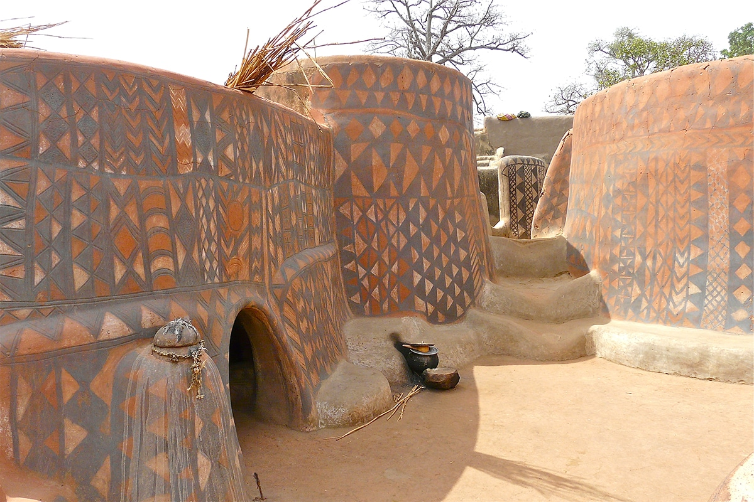

Figure 1: Font Georgia, size 10, centre-aligned. The picture size should not be bigger than the size of the lines in the paragraphs.

If you are using table, use font size 10.

**Heading 2: If it is a section, use size 12.**

**Heading 2 [size 11, justified, spacing before and after 6, line spacing Single all over the body of the article. In case of quotation of poems use spacing before and after 0]**

**Acknowledgment**

Font style: Georgia, Font size: 12

**Declaration of Conflicts of Interests**  
The author(s) declared no potential conflicts of interest.

**Funding Disclosure/Acknowledgement**

Include your institutional funding information here.

**Notes:**

[Font size 10, spacing before and after 0, line spacing 1.15, justified]

Better to avoid using notes. Try to incorporate the information inside the main body of the article as much as possible.

Use MS Office’s inbuilt system of inserting Endnotes or convert footnotes to Endnotes. Follow Roman numerals (i, ii, iii) for numbering.

**References [Font size 10, spacing before and after 0, line spacing 1.15]**

Bate, J. (1999). Shakespeare and original genius. In P. Murray (Ed.), *Genius – The**History of an Idea.* New York: Basil Blackwell. 76–97 **[Note first line indent and Left Indent]**

Author’s bio-note goes here. Font Georgia, size 11, spacing 0, line spacing single, justified.